    - CURRENT SOFTWARE ARCHITECTURE

Currently there are some software architecture for the Restaurant Finder. When the customer use this program, they can find every restaurant where he/she wants. Our program seems to be useful and friendly for our customers. Also we want this program helps the customers to find new restaurants.
Nowadays, there are lots of restaurant finder systems, but our program is not the same others. We developed the software for the using RestaurantFinder easily. On the other hand there 2 type search button. One of them is, entering city where the customers want to find in restaurant and other one is searching restaurant with using restaurant's name. Also we used database system for customers can reach their favorite restaurants.
RestaurantFinder program have restaurants information in its database. When the customers want to reach restaurant information such as telephone number, location etc. they can be reach. Because of this, customers can trust our program. It has not got any unreal informations about restaurants that are including our database system.
In our software about the RestaurantFinder, we used admin page to select restaurants that can have best quailities. We cannot select restaurants which have got any worse comments.
To conclude, our program, which is name RestaurantFinder, is very useful and understandable software.

  - PERSISTENT DATA MANAGEMENT

RestaurantFinder is using database to store all restaurants and customers informations. Also database should store cities. They must be relation in each other.
RestaurantFinder's database name is restaurant. We used 4 tables such as iller, login, restaurantlar and rezervasyon. Also maybe we can change some variables on the database.
In this program, we use phpMyAdmin. It is very useful interface to create a database.
We use insert, delete, search etc. methods.
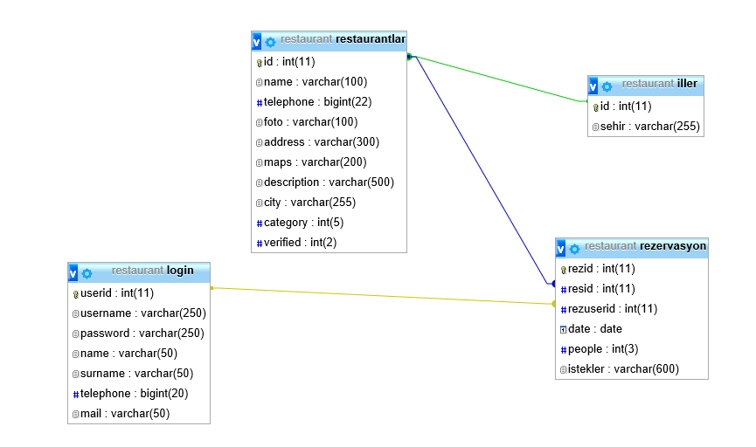

RestaurantFinder's database keeps relations. We use id for making tables unique.

Description of the Tables

Login: Login table where we store customers' information. It has 7 fields which are userid, username, password, name, surname, telephone, mail. All these fields helps the customers to access their page.

Restaurantlar: Restaurantlar table where we store restaurants' information has 10 fields which are id, name, telephone, foto, address, maps, description, city, category, verified. All these fields helps the system to access restaurant's information.

İller: İller table where we store cities' name has 2 fields which are id and sehir. 'sehir field helps the relation in the system. Customers use the 'sehir' to find the restaurants.

Rezervasyon: Rezervasyon table where we use for the main topic has 6 fields which are rezid, resid, rezuserid, date, people, istekler.

